**DAILY ONLINE ACTIVITIES SUMMARY**

|  |  |  |  |  |  |  |  |  |
| --- | --- | --- | --- | --- | --- | --- | --- | --- |
| **Date:** | **20-07-2020** | | | | | **Name:** | **D Jasmine Joyline** | |
| **Sem & Sec** | **VI Sem A** | | | | | **USN:** | **4AL17CS024** | |
| **Online Test/**  **Pre-placement Training Summary** | | | | | | | | |
| **Subject** | | **OS IA DESC-2** | | | | | | |
| **Max. Marks** | | **-** | | **Score** | | | **-** | |
| **Online Certification Summary** | | | | | | | | |
| **Course** | Python | | | | | | | |
| **Certificate Provider** | | | **Coursera** | | **Duration** | | | **-** |
| **Coding Challenges** | | | | | | | | |
| **Problem Statement:** | | | | | | | | |
| **Status:Completed** | | | | | | | | |
| **Uploaded the report in Github** | | | | | **Yes** | | | |
| **If yes Repository name** | | | | | <https://github.com/alvas-education-foundation/D_Jasmine_Joyline/tree/master/daily_progress> | | | |
| **Uploaded the report in slack** | | | | | **Yes** | | | |

Online Test Details:

OS Descriptive IA Test 2

Online Training Details:

Online Certification Details:

Python Course

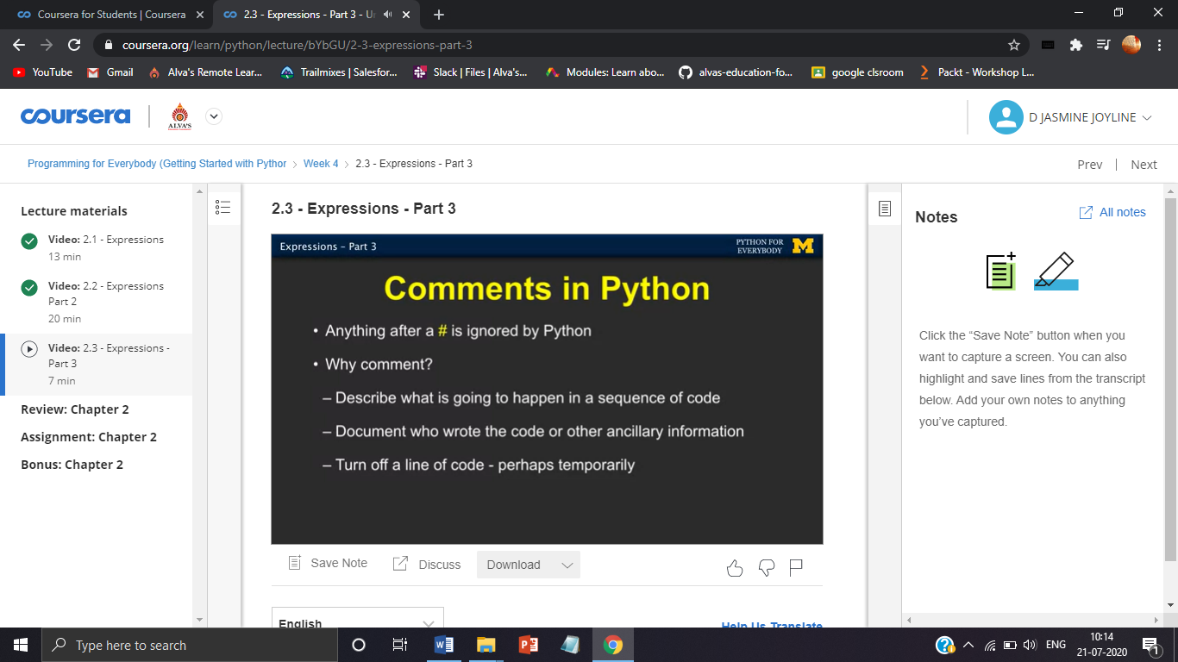

Coding Challenges Details:

-